The film and television industry plays an important role in New York City's economy and cultural landscape. My findings aim to analyze the film permit data in New York City from January 2023 to April 2024 and explore patterns in filming activity across the city’s boroughs, production types, and seasons. By incorporating weather data, I also aimed to investigate the relationship between temperature and filming frequency. The primary data source for this analysis is the Film Permit dataset provided by NYC Open Data, which provides comprehensive information on film permits issued throughout the city (NYC Open Data, 2024). For weather data, I opted to go with historical weather information provided by the National Weather Service (National Weather Service, 2024).

One of the initial challenges in this project was data preparation. The raw data from NYC Open Data required extensive cleaning and formatting to make it useable for analysis in Tableau. This process involved standardizing date formats, categorizing production types, and aggregating data by borough and zip code. Additionally, merging the film permit data with weather information was a challenge, particularly in aligning the dates and times. I was able to overcome these challenges by using my computer science background knowledge to write Python scripts. I wrote one script that was able to subset data to make it easier to read in external applications, and another to merge my two datasets by row, matching the cells by date. I have provided the source of these files at the bottom of this document for further context.

The analysis of borough distribution revealed that Manhattan is the most popular in terms of film permits issued, followed by Brooklyn, Queens, the Bronx, and lastly Staten Island. This distribution likely occurs due to Manhattan's iconic status in film and television, as well as its diverse landscape that appeals to different filmmakers. Interestingly, while Manhattan leads in all categories, Brooklyn shows a particularly strong presence in television production. This might suggest that Brooklyn is becoming a significant hub for TV production, and this could be due to its diverse neighborhoods and more affordable filming locations when compared to Manhattan (NYC Film and Television Industry Economic Impact Study 2021).

After I examined the permits issued per borough by category, I decided to go further in comparing production types between Manhattan and the rest of the boroughs. To do this I decided on a dual pie chart, and I found that Television production is the dominant category across all boroughs. However, theater productions have a significantly higher share in Manhattan (15.6%) compared to other boroughs (4.4%). This difference shows how strong Manhattan's theater culture is and is likely due to the famous Broadway district. Commercial and film productions meanwhile show similar proportions across Manhattan and other boroughs, suggesting that these types of shootings are more evenly distributed throughout the city.

To take it a step further, I decided to check the general filming locations within the other boroughs to see if there were any interesting hotspots. Long Island City in Queens was by far the most popular location for TV production in these boroughs. On the other hand, the Bronx had significant activity in Clason Point and Mott Haven. These concentrations might be due to the presence of studio facilities or diverse filming locations. Additionally, the Bronx is known to be the birthplace of rap and hip-hop music, and so this could be correlated with an increase in recording studios and similar filming and recording facilities. (2022 NYC Publishing Industry Economic Impact Study).

One of the more interesting aspects in my analysis was the exploration of temporal trends in film production. The data revealed patterns across different categories, with television production showing the most pronounced seasonal variation. There were also peaks in TV production seen in the spring and fall, with a significant dip in the summer across almost all production types. Theater productions peaked in the late summer, possibly aligning with the traditional theater season of the city. Commercial and film productions showed less dramatic seasonal fluctuations but did seem to increase in the spring and fall as well. These patterns suggest that the film industry adapts its production schedules to some sort of cultural pattern.

I wanted to explore if the weather had any impact on these temporal trends, or if the trends were mostly on a basis of culture and schedule. By comparing film permit counts with average monthly temperatures, I noticed a definite inverse relationship existed, especially for television productions. Most filming seems to occur during months with moderate temperatures, matching the spring and fall, while the lowest number of permits are issued during the hottest and coldest months of the year. This suggests that production schedules are heavily influenced by weather conditions, likely due to the challenges of filming outdoors in extreme temperatures. This leads me to wonder if the previously mentioned cultural trends were originally formed on a climate basis.

In conclusion, while Manhattan dominates in overall permits issued, the seasonal trends show that this dominance may fluctuate throughout the year. The concentration of theater permits in Manhattan fits with its known Broadway culture, whereas the strong showing of TV production in areas like Long Island City shows that outer boroughs may be developing specialized niches in the film industry. Overall, my analysis reveals a complex interplay between location, production type, season, and weather in New York City’s film industry. This helps give a platform to create informed decision-making for industry professionals and policymakers, helping to the growth and sustainability of the city’s important role in film production.

Below are the Python scripts that I wrote, used for data cleaning, formatting, and merging:

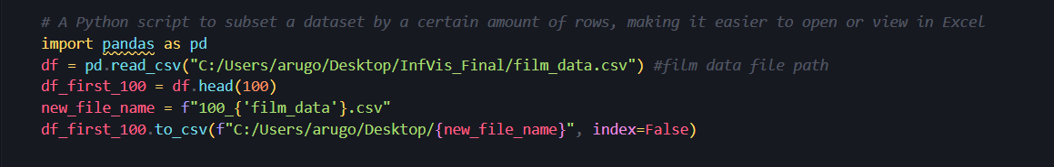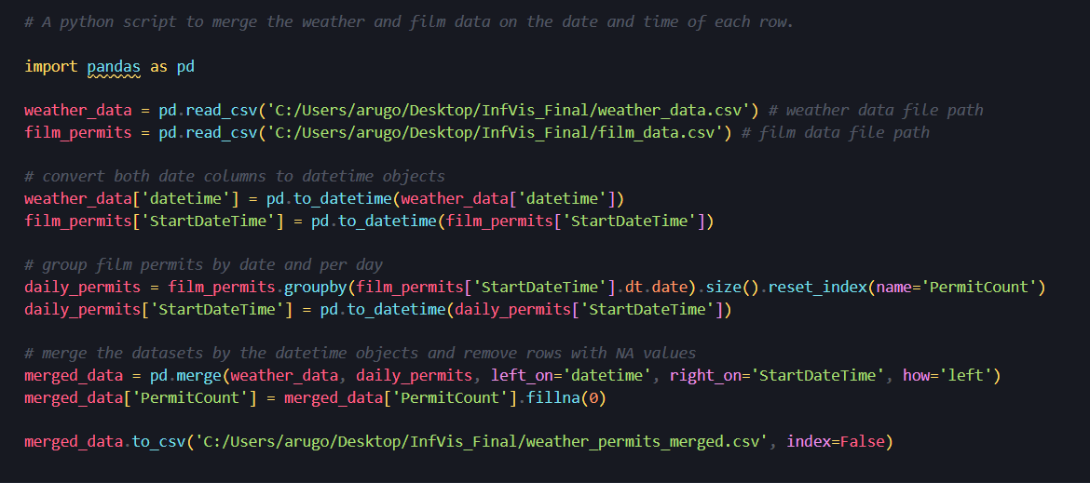

References

Mayor's Office of Media and Entertainment. (2024, July 21). NYC Film Permits. NYC OpenData. https://data.cityofnewyork.us/City-Government/Film-Permits/tg4x-b46p/about_data

National Weather Service. (2024). Historical Weather Data. https://www.weather.gov/

New York City Mayor’s Office of Media and Entertainment. (2022, December 1). *2022 NYC Publishing Industry Economic Impact Study* (A. del Castillo, Ed.) [Review of *2022 NYC Publishing Industry Economic Impact Study*]. Mayor’s Office of Media and Entertainment; Search City of New York. https://www.nyc.gov/assets/mome/pdf/NYC-Publishing-Industry-Economic-Impact-Study.pdf

New York City Mayor’s Office of Media and Entertainment. (2021, September 15). *NYC Film and Television Industry Economic Impact Study 2021* (A. del Castillo, Ed.) [Review of *NYC Film and Television Industry Economic Impact Study 2021*]. Mayor’s Office of Media and Entertainment; City of New York. https://www.nyc.gov/assets/mome/pdf/FilmTV_report_091521.pdf